InnoAiSmartNotes Documentation

1. Project Overview
InnoAiSmartNotes is an AI-driven knowledge lifecycle management platform consisting of three primary modules:
• Student Module
• Professor Module
• Admin Module
The Admin Module functions as the governance authority, authentication authority, institutional control layer, and system-level analytics controller.
The backend architecture has been initialized using FastAPI with MongoDB Atlas as the primary database system.

2. Backend Architecture Overview
Technology Stack:
• Backend Framework: FastAPI
• Database: MongoDB Atlas
• Authentication: OAuth2 + JWT
• Password Hashing: bcrypt (via passlib)
• Token Security: python-jose
• Configuration Management: pydantic-settings
• Environment Variables: .env file
• API Documentation: Swagger (auto-generated)
The architecture follows a modular monorepo structure with clear separation of concerns.

3. Project Structure
Monorepo Architecture:
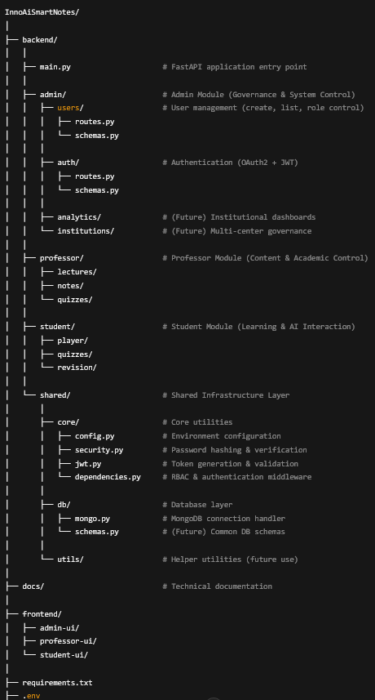
Design Decisions:
• Each module is isolated for scalability.
• Shared logic resides under /shared.
• Clean separation allows independent scaling of modules.

4. Database Integration (MongoDB Atlas)
MongoDB Atlas was selected due to:
• Flexible document-based storage
• Suitability for AI/ML metadata
• Horizontal scalability
• Managed cloud infrastructure
Implementation Completed:
• Atlas cluster created
• Database user configured
• IP whitelisting configured
• Secure connection string stored in .env
• Centralized connection logic implemented
• Startup/shutdown lifecycle integrated
Health Check Endpoint:
GET /db-check

5. Authentication System (OAuth2 + JWT)
Authentication Flow:
1. User submits credentials.
2. Password verified via bcrypt hash comparison.
3. JWT token issued.
4. Token includes:
- sub (user ID)
- role
- expiration
JWT Configuration:
• HS256 Algorithm
• Configurable expiration time
• Secrets stored in environment variables
Endpoint:
POST /auth/login

6. Role-Based Access Control (RBAC)
RBAC Implemented Using:
• get_current_user() dependency
• require_admin() middleware
• Token decoding and validation
• User retrieval from MongoDB
• Role verification
Admin-only endpoints protected using dependency injection to prevent privilege escalation.

7. User Management System
Implemented Endpoints:
POST /users/
• Email uniqueness validation
• Password hashing
• Timestamp insertion
• Returns inserted user ID
GET /users/
• Removes password field
• Converts ObjectId to string
• Returns clean JSON response

8. Security Hardening Measures
Security Measures Implemented:
• Password hashing (bcrypt)
• JWT expiration handling
• Role-based endpoint protection
• Secure environment variable usage
• No plaintext passwords stored
Development Issues Resolved:
• Pydantic v2 migration
• email-validator dependency
• bcrypt backend compatibility
• MongoDB authentication errors

Current State
System Status:
✓ MongoDB Atlas connected
✓ FastAPI running
✓ OAuth2 login operational
✓ JWT generation functional
✓ Role enforcement active
✓ Admin-only endpoints protected
✓ Swagger authorization working
✓ Clean modular code structure

